NOBUGS 2008

Mantid: Manipulation and Analysis Toolkit for ISIS Data

Author(s): N. J. Draper, R. J. Taylor, R. Tolchenov, M. J. Clarke, A. J. Markvardsen, S. Nagella, R. Fowler, F. A. Akeroyd, L. C. Chapon, P. G. Radaelli, T. G. Perring
Organization: ISIS Facility, Rutherford Appleton Laboratories, STFC

Abstract
The expansion of ISIS with Target Station 2 brings further data reduction and analysis challenges that the current software packages cannot handle. To address this, the Mantid project provides an extensible data reduction and analysis framework for neutron and muon data that is independent of instrument and analysis technique. Mantid is a joint collaboration between ISIS and Tessella.
The Mantid framework provides support for visualization and data transformation. It allows the user to implement their own tailored analysis algorithms, and maintains a full virtual instrument geometry. Various input and output file formats are supported including NeXus files and loading direct from the ISIS data acquisition electronics.
Mantid can be easily extended using a plug-in mechanism to add further user-defined algorithms, data structures and file formats. It has been developed using object-oriented C++ for execution performance and portability and makes use of several publicly available libraries such as BOOST and GSL. Care has been taken to isolate as much complexity as possible from the areas that may be extended by users, while providing them with powerful objects to manipulate their data.
MantidPlot, a generic visualization and algorithm execution application, is the first graphical user interface that has been developed to use Mantid and also provides Python scripting capabilities. Mantid itself currently provides C++ and Python APIs and work has begun on providing a MATLAB interface.
The Mantid project is being developed and released publicly (www.mantidproject.org) under the GNU General Public License for use within the wider neutron community.

Introduction
The Mantid project has been established to support the data reduction and analysis needs of all of the beamlines at the ISIS facility in a way that has not been attempted before. Previous software projects at ISIS have generally concentrated on the needs of a few of the beamlines with the result that wider acceptance has been limited. Mantid is the first software project at ISIS to be fully funded and have a core of full time developers solely working on Mantid. The project is a joint collaboration between the ISIS facility and the specialist scientific software consultancy Tessella, who provide the project management and significant development expertise.
The primary aims of the Mantid project are:
- To provide a framework for Data Analysis that is not instrument or technique dependent.
- Support multiple target platforms (Windows, Linux).
- Easily extensible by Instrument Scientists/Users.
- Freely redistributable to visiting scientists.
- Provide low-level functionalities for
  - Scripting
  - Visualization
  - Data transformation
  - Implementing Algorithms
  - A Full Virtual Instrument Geometry

Project Organisation
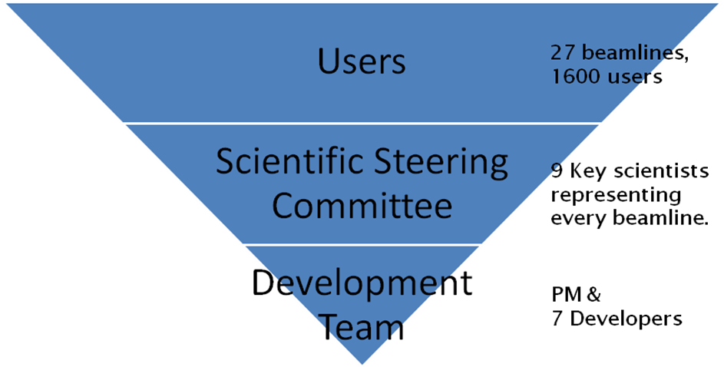
The ISIS facility currently supports 1600 users across 27 beamlines, although this number will increase as new beamlines are built in Target Station 2. This is of course too many users for any software project to hope to interact with directly. To ensure we have a broad coverage of all of the issues and needs of the beamlines a scientific steering committee has been established with at least one key scientist from each group of beamlines. The Committee work together to identify areas for future development, prioritise the various tasks and maintain communication between the project team and the wider user group.
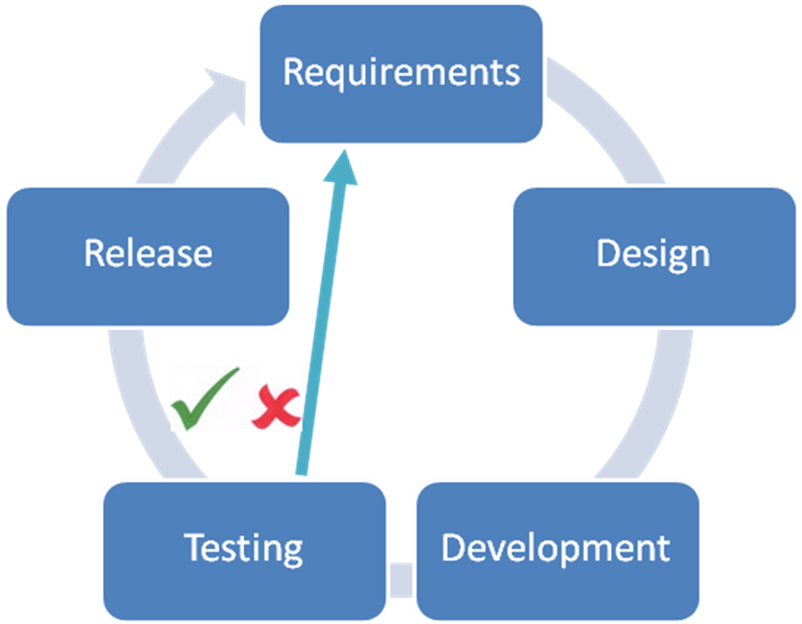
Mantid is developed using an iterative development process using 1 month iterations leading to a testable product each month. If final system testing through the user interfaces passes then that version will be released to all users through the project website. If a release fails testing for a significant reason then that release will normally be abandoned while issues are corrected in time for the next month’s release.
In order to help the development team maintain the quality of the software we develop in a continuous integration environment. Developers check in their work to the project SVN repository as frequently as practical. With each checkin two build servers (one Windows and one Linux) immediately build and run the entire unit test suite (currently 914 individual tests) in order to highlight any failures due to coding errors or unexpected side effects. The feedback loop is closed with email reports from the build servers to the entire development team.

Design

Design Criteria
During the requirements a few solid design criteria were identified:

Clear separation between “data” and “algorithms”
This separates operation on data from the structures holding the data themselves. While this is normally opposed to the principles of object oriented software design, for this type of project it makes a lot of sense. Given for example a 2D histogram of neutron counts there are numerous different operations or algorithms you may want to act on this data. Having every operation detailed on that object would be very unwieldy as well as become difficult to use. Perhaps more importantly you may want to add a few new algorithms that were not previously thought of. By separating the data objects from the algorithms that act on them we keep each algorithm and each data object as simple as possible. This way we adhere to another important design principle, that each object should one thing well; each data object simply stores its information, while each algorithm simply knows how to manipulate the data to create a “result” data object. Separating the algorithms also has the effect of making it much easier to allow users to add their own algorithms to the framework.

Clear separation between “persistent data” and “transient data”
By separating the persistent data (i.e. the data as saved in a raw or Nexus file) from the transient data (the in-memory representation of the data) we gain independence from any particular file format or even type of persistent store (file structures, relational databases etc). This means that algorithm code can be written without any knowledge of how the data objects are saved or loaded, or what format the data will be saved in. We also gain the flexibility to optimise the in memory data storage and persistent data storage separately. Finally by encapsulating the code to interface with data in persistent store within defined objects within the Framework we minimise the risk and simplify the task of adding support for new file formats in the future.

Data centred architectural style
By centring the architecture on the data and algorithms we will ensure that the creation and maintenance of both are as simple as possible. Using the separation of the data objects from the algorithms themselves we minimise coupling between implementations of different algorithms which will allow several developers to work in this area concurrently.

Encapsulating “User Code” localized in a few specific places
The need to customize the framework by adding new algorithms, data objects and services is paramount, both by end users as well as specific data analysis applications. By creating specific abstract classes that can act as base classes for any user created objects we can simplify the interface between the user code and the framework internals. Therefore the job of extending the framework will be simpler and the resulting code more maintainable.

All components with well defined interfaces
Each component of the architecture will implement a number of interfaces (pure abstract classes in C++) which will be used for interacting with other components within the framework. Each interface consists of a set of functions which are specialized for some type of interaction. The intention is to define these interfaces in as generic a way as possible. That is, they should be independent of the actual implementation of the components and also of the concrete data types that will be added by the users when customizing the framework.

Architectural Design - Overview
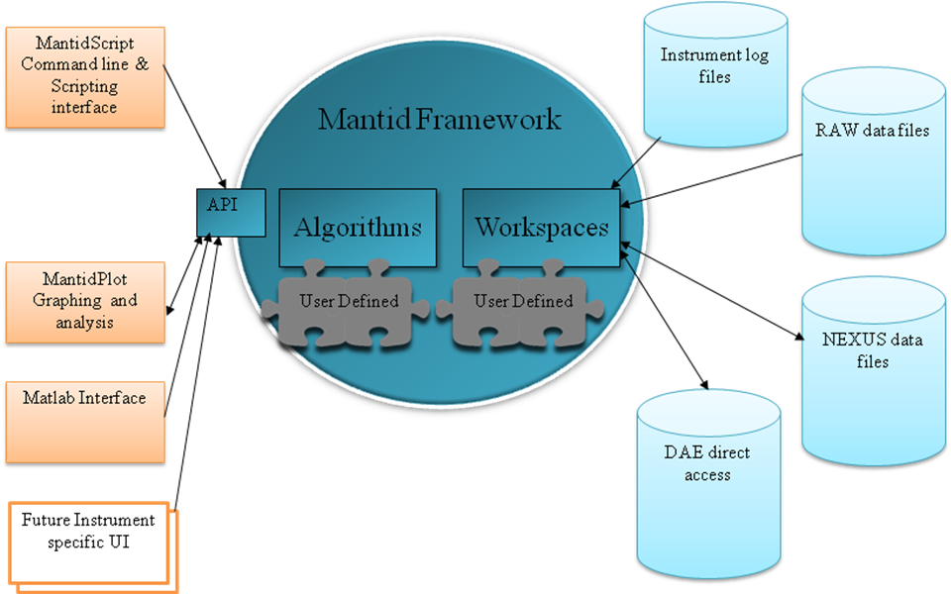
At the heart of the Mantid system is the Mantid framework where all of the data and analysis code is centred. The centralisation of all of our code in a framework that is independent of any visualization greatly eases the task of introducing new user interfaces and maintaining multiple user interfaces as each is only concerned with the presentation of data to users, all data manipulations are done using the framework. So far we have built three user interfaces: a graphing and analysis tool called MantidPlot that has been built as an extension to the open source project QtiPlot, a Python interface called MantidScript that provides us a command line and scripting interface, and an interface that allows control of the Mantid framework from within Matlab.
The framework itself is built around two main concepts: algorithms that can manipulate data and workspaces that hold the data. The rest of the framework provides useful services to those two main concepts. While there are many algorithms and workspace types already built for the framework Mantid provides a plug in system to greatly ease the task of adding new algorithms or workspaces should a user require a manipulation that we have not provided.
Data input and output is also provided using specialized algorithms. Currently we can access the data in ISIS RAW and NEXUS files, as well as instrument log files and instrument definition files. We have also developed a solution to access the data directly from the data acquisition electronics, either at a single point in time or repeatedly refreshing the data after a set time period.

Geometry

Approaches for Computational Geometry
One of the main aims of the Mantid project was to store the full virtual instrument geometry of all of the important components of an instrument. There are two main approaches to representing geometry within software. One is to store a triangular mesh representation of each object, and the other is to use the underlying surface equations of objects to represent them. The figure below shows a simple sphere represented in both approaches and the computational path of an incident neutron together with its reflection for each.
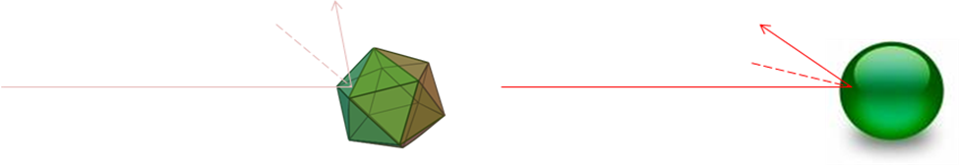
Mesh Based
Surface Based
This highlights one of the disadvantages of the mesh based approach, where imperfections in the triangulated approximation of the surface can significantly alter the results of calculations. A study we performed suggested that for a triangulated sphere to acceptable approximate a real sphere it would need to be created from 1000 triangles and at this scale performance of simple intersection calculations can increase significantly. Of course the surface based approach also has its weaknesses; one is that while simple surface equations exist to describe many primitive shapes it is not easy to provide equations to define more complex shapes used in real life instruments, the other is that visualization techniques used in computer graphic hardware are designed for mesh based geometry, making the efficient visualization of surface based geometry a difficult problem.

Mantid’s Approach to Geometry
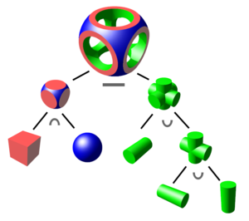
Mantid primarily uses surface based geometry to define the instrument internally for reasons of computational speed and accuracy, but we have taken various approaches to minimise or eliminate the problems associated with this approach. We have designed the system to allow for the use of Constructive Solid Geometry (CSG, show in the diagram to the right) to build complex objects through the use of Boolean intersection, union and difference operations on various primitives. This has proved to be both powerful, but also well understood by users.
In order to solve the problem of visualising these surface-based CSG objects efficiently we taken a hybrid approach to leverage the benefits of both approaches to geometry. As mentioned earlier Mantid stores the instrument components as a construction of surface base primitives formed together using CSG. This representation is used for the definition of the instrument and also for calculations. When we need to visualise the instrument we convert our surface based representation to a triangulated mesh representation using the GNU triangulated surface library. This allows the use of standard OpenGL techniques to efficiently visualise the instrument.

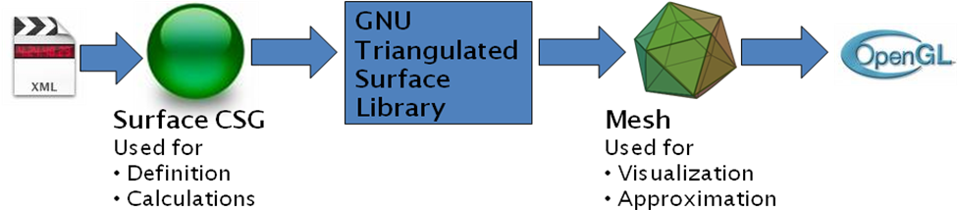

Scripting for an Extensible Framework
Mantid is written to be extensible through a plugin system that can extend the algorithms available at run time. When the framework starts up it reads all libraries in the defined plugins directory and includes any algorithms or workspaces it finds and makes them available just like any other algorithms. This flexibility can make it more difficult to write an effective API for the framework, as the list of algorithms and their required inputs is not known until run time. Mantid initially took the approach of providing a very generic API, where to run an algorithm you called a method specifying the name of the algorithm in a string and all of the required inputs in another string
For example:
mantid.exec(“LoadRaw”,”ws1;c:\myFiles\ins001.raw”)
This was far from ideal as it mixed the algorithm’s list of inputs into a single string that had to be parsed to extract the information. It was also not well received by users who were unused to object oriented development or such an abstract approach. The users wanted to be able to call a command directly by it name rather through another object or method.
Mantid solves this problem by delaying the writing of the API until run time. Once a user starts up the scripting API (either Python or Matlab) the framework writes out a simplified API once all of the plugins have been loaded. At this point the framework knows all of the algorithms and their parameters and can create specific methods for each one, in addition help can be created for each algorithm to detail the required inputs. This provides the much simpler interface the users desired.
For example:
LoadRaw(“ws1”,”c :\myFiles\ins001.raw”)

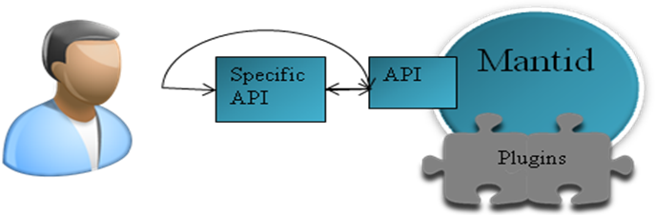
Initial Call forces the writing of the specific API
Subsequent calls

Future
The future holds many challenges for the Mantid project. We need to increase the support for the data reduction and analysis algorithms needed by the various beamlines, and therefore further the use of Mantid by these groups. Mantid will also be used in the commissioning of several of the new instruments in Target Station 2 over the next few months. Many of these new instruments give larger challenges both in the volume and complexity of the data that will be captured, but also in the analysis required, and Mantid will need to be able to support these.
As the set of available algorithms expands and becomes more stable we will move into other areas that are supported by the design of the Mantid framework including the integration of Monte Carlo techniques or packages to allow for instrument simulations. We will also be providing support for visualising large multi-dimensional data sets, probably by extending the Paraview open source project.
Finally we would like to encourage and support the use of Mantid throughout the wider neutron community, both through adoption and use at other facilities but also through integration with other software projects. Mantid is developed and released under the GNU General Public License and is free for anyone to use and extend to fit their needs.

Further Information
Project Web Page
www.mantidproject.org
Project Introduction Document
http://svn.mantidproject.org/mantid/trunk/Documents/Requirements/Project%20Introduction%20Document.doc
User Requirements Document
http://svn.mantidproject.org/mantid/trunk/Documents/Requirements/URD.doc
Architectural Design Document
http://svn.mantidproject.org/mantid/trunk/Documents/Design/Architecture%20Design%20Document.doc

